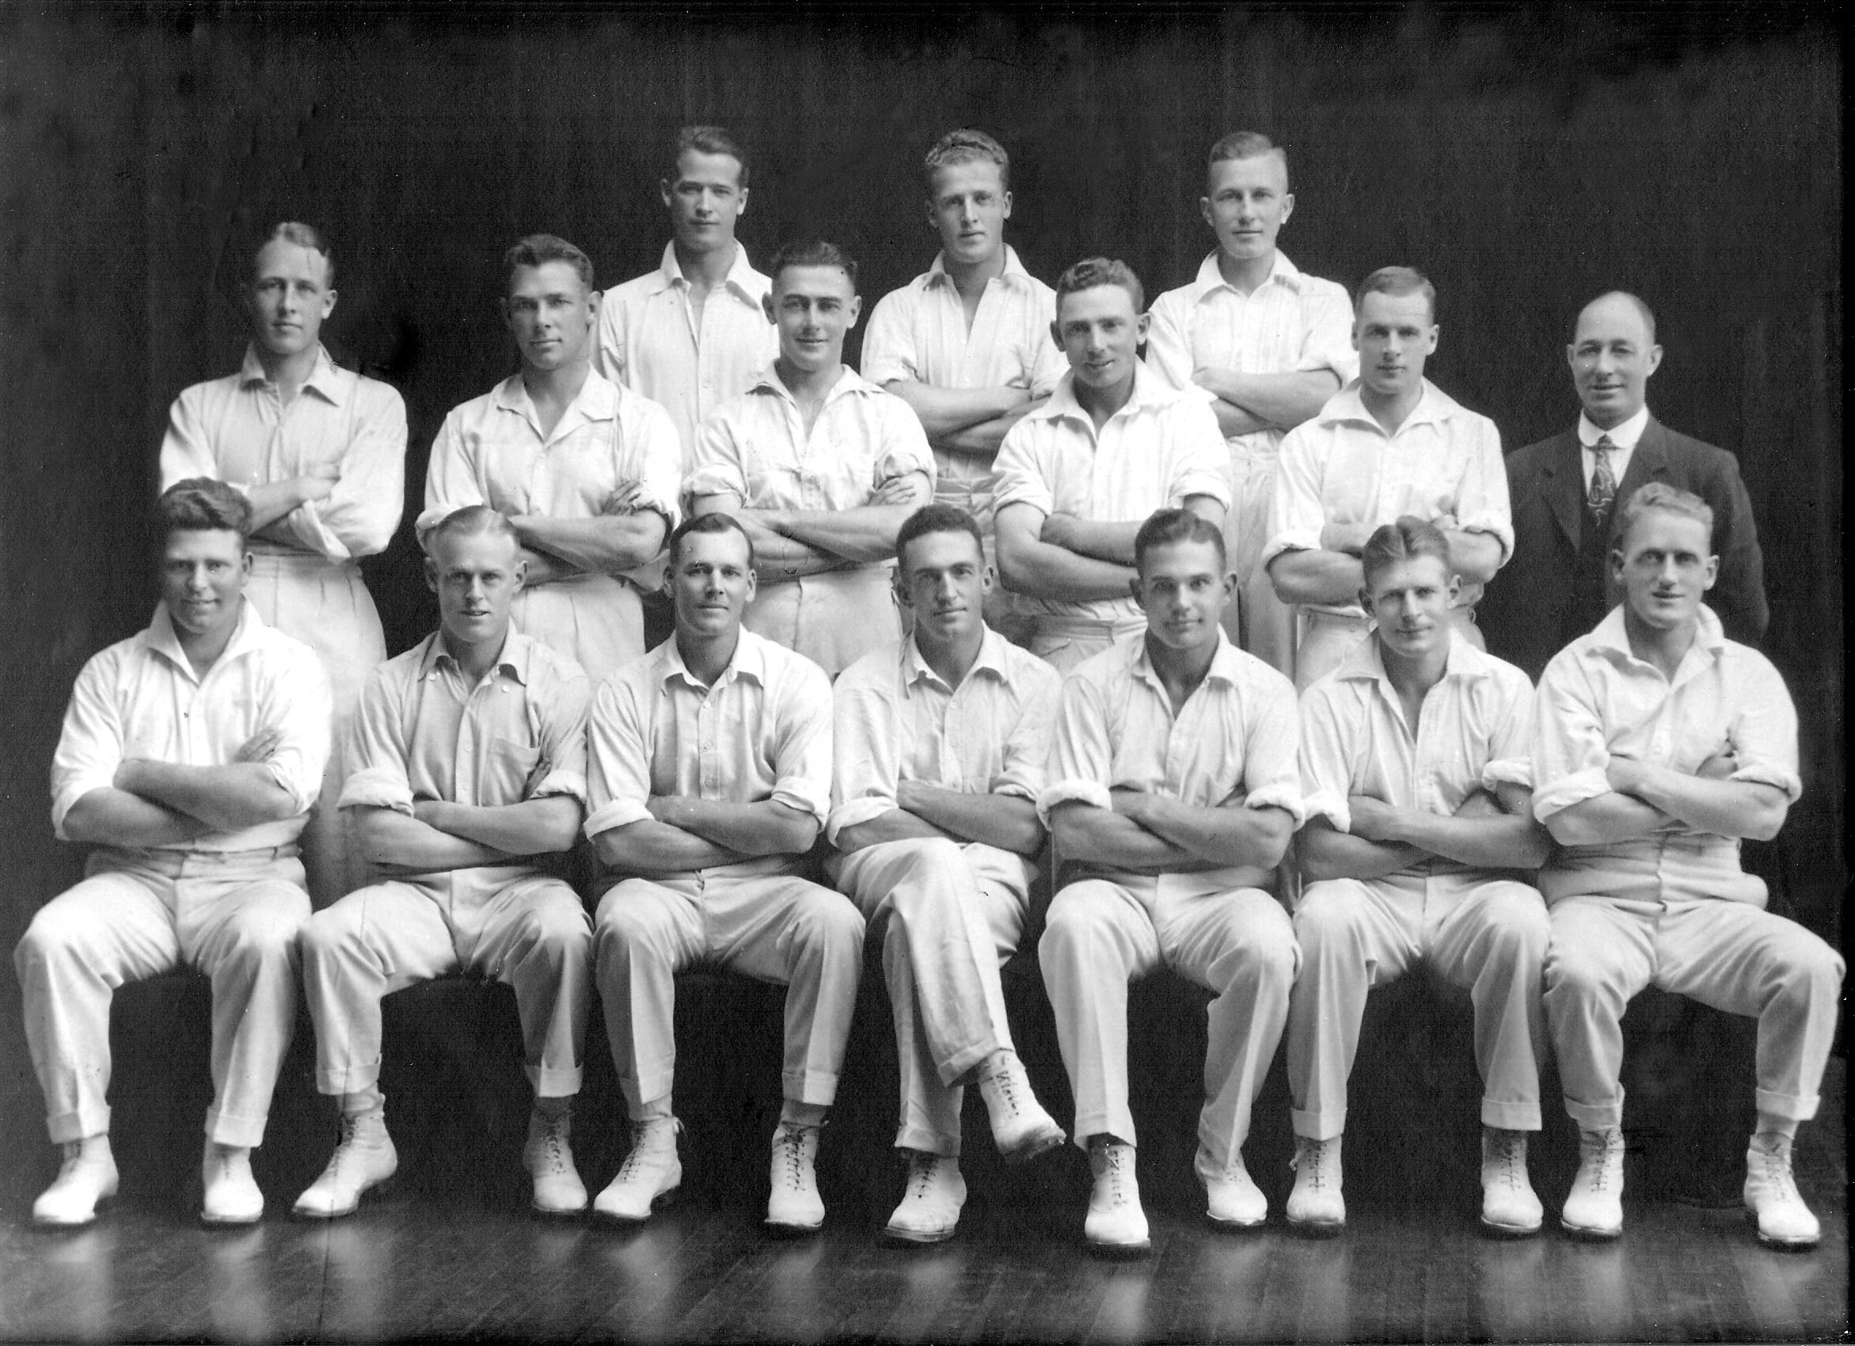

**Canterbury Representative Team 1930-31 Season**

Winners of the Plunket Shield

**Back row:** WE Merritt, J Jacobs, CG Crawford

**Middle row:** SG Lester, JT Burrows, IB Cromb, WHR Cunningham, IM Hamilton, WL King (manager)

**Front row:** T Kennedy, RO Talbot, RJ Read, ML Page (captain), AW Roberts, JL Kerr, NR Dorreen